Name: Shay Walker

Box #613

Professor Sabal

Cairn University School of Business

CIS122 Essentials of Networking

Project #5

Project objective:

Define the steps that will be taken in order to set up a DHCP Server on a Linux operating system. This would only need to be done for networks that are still using IPv4, due to the fact that IPv6 does not need the services of the DHCP Server.

Dynamic Host Configuration Protocol (DHCP) automatically assigns IP addresses and other network configuration information (subnet mask, broadcast address, etc.) to computers on a network. A client configured for DHCP will send out a broadcast request to the DHCP server requesting an address. The DHCP server will then issue a "lease" and assign it to that client. The time period of a valid lease can be specified on the server. DHCP reduces the amount of time required to configure clients and allows one to move a computer to various networks and be configured with the appropriate IP address, gateway and subnet mask. For ISP's it conserves the limited number of IP addresses it may use. DHCP servers may assign a "static" IP address to specified hardware (http://www.yolinux.com/TUTORIALS/DHCP-Server.html).

Equipment used:

|  |  |  |  |  |
| --- | --- | --- | --- | --- |
| Equipment Description | Vendor | Vendor Item # | Retail price | Actual price (if known) |
| Lenovo ThinkSystem SR550 - rack-mountable - Xeon Silver 4110 2.1 GHz - 16 GB - 0 GB | Zones | 005035596 | $2,533.99 | N/A |
|  |  |  |  |  |

Detailed list of software and operating platforms used, including version numbers and licensing requirements: (Linux operating system)- Ubuntu

**Network diagram:**

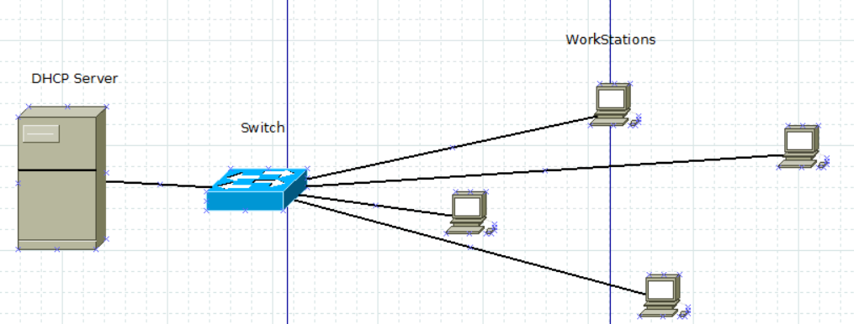

**Configurations:**

1. **Install the dhcp server**

Ubuntu/Debian 8: apt-get install dhcp3-server

( Later releases of Ubuntu (11.04) used the busybox release known as udhcpd and the configuration is NOT shown here)

**2. Start the server**

/etc/init.d/networking restart

**3. Retrieving the DHCP File to access the information necessary**

/etc/dhcpd.conf

**4. Subnet and netmask displayed**

subnet 192.168.1.0 netmask 255.255.255.0 {

**5. Global Parameters: Defining the addresses that can be given**

range 192.168.1.128 192.168.1.254;

**6.Options for Subnet-mask, Broadcast address, Default gateway address, Domain Name, DNS Server**

option subnet-mask 255.255.255.0; # Default subnet mask to be used by DHCP clients

# Default broadcast address to be used by DHCP clients

option broadcast-address 192.168.1.255;

# Default gateway to be used by DHCP clients

option routers 192.168.1.1;

option domain-name "your-domain.org";

# Default DNS to be used by DHCP clients

option domain-name-servers 40.175.42.254, 40.175.42.253;

**7. Assigning a Lease Time to the server addresses: You can assign the amount of time in each lease and the max time limit will also be displayed**

default-lease-time 21600;

max-lease-time 43200;

**8.If you want to give a specified MAC address you can assign one**

host ns2 {

next-server ns2.your-domain.com;

hardware ethernet 00:02:c3:d0:e5:83;

fixed-address 40.175.42.254;

}

**9. You can define specific IP addresses for devices on your network that may need to be assigned an address**

# Laser printer obtains IP address via DHCP. This assures that the

# printer with this MAC address will get this IP address every time.

host laser-printer-lex1 {

hardware ethernet 08:00:2b:4c:a3:82;

fixed-address 192.168.1.120;

}

# Do not forget the ending Bracket

}